Architecture Development Part 2: Installation, Configuration, and Security of OpenEMR
1.0.Web page screenshot (the screenshot must include the IP Address of each hospital) of each hospital's successful installation of OpenEMR (8 points)
Aspirus Hospital Webpage Screenshot(2 points)

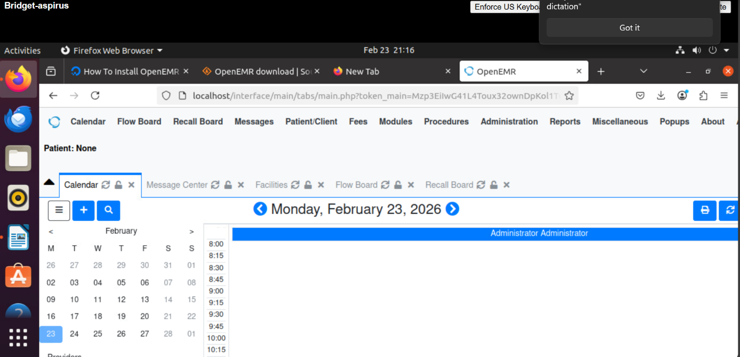

Baraga County Memorial Hospital (BCMH)Webscreenshot (2 points)
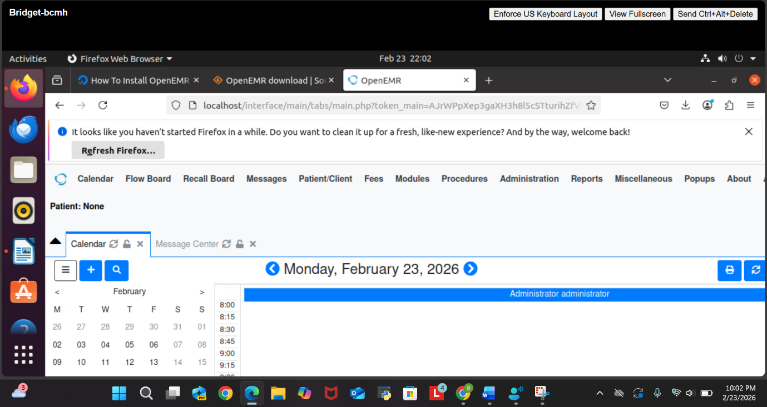

Portage Health Hospital Webscreenshot(2 points)
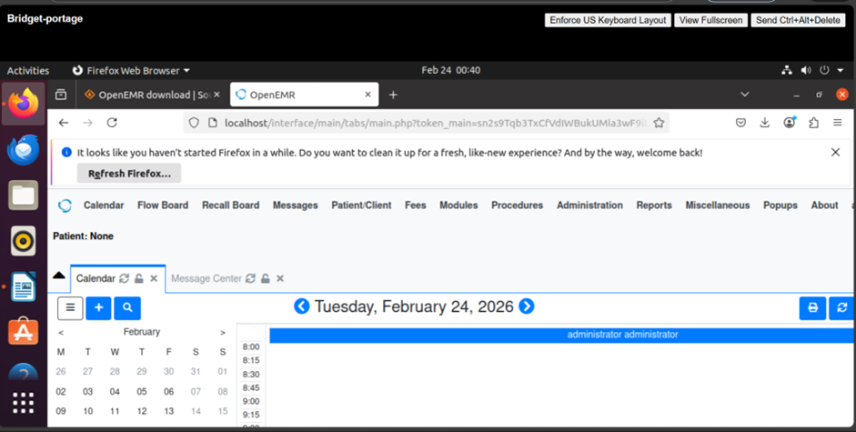

Marquette General Hospital (MGH) Webscreenshot(2 points)

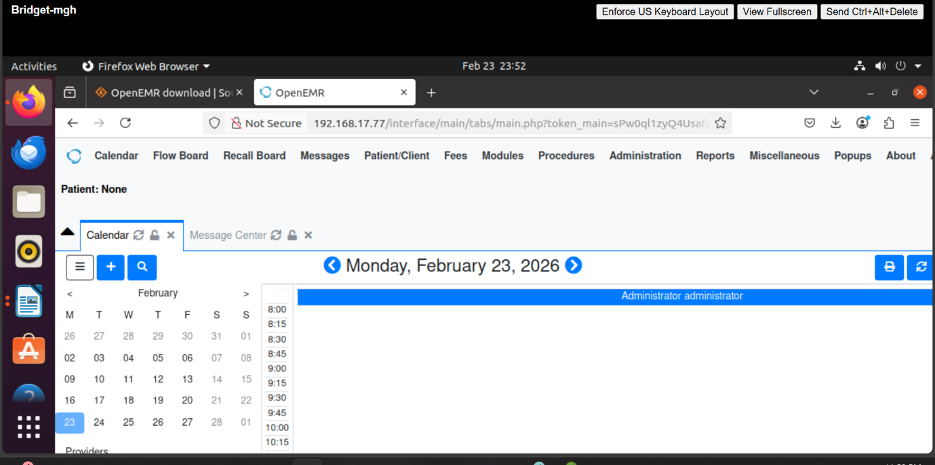

B. Show the steps and commands you used to secure OpenEMR (10 points)
During the installation of OpenEMR, I first ensured that my system was fully updated with the
latest security patches. I ran sudo apt-get update followed by sudo apt-get upgrade to make sure
all existing packages and system libraries were current and secure before installing the
application.

Next, I configured automatic security updates to keep the system protected without requiring
manual intervention. I installed the unattended upgrades package using sudo apt-get install
unattended-upgrades and enabled it with sudo dpkg-reconfigure --priority=low unattended-
upgrades. This ensured that future security patches would be applied automatically.

I then installed and configured the Uncomplicated Firewall (UFW) to control incoming and
outgoing traffic. I used sudo apt-get install ufw to install it, allowed necessary services with
sudo ufw allow http and sudo ufw allow ssh, and activated the firewall using sudo ufw enable.
This restricted access to only essential services and reduced exposure to unauthorized
connections.

To further secure the web server, I hardened the Apache configuration by editing the security
settings with sudo nano /etc/apache2/conf-available/security.conf. I enabled important security
headers to protect against common web-based attacks and reduce server information exposure.

Finally, I secured the MySQL database by running sudo mysql_secure_installation. During this
process, I set a strong root password, disabled remote root login, and removed anonymous users
to prevent unauthorized database access and strengthen overall system security.

C. What other types of attacks would still be sucesptible to the OpenEMR platform? (2 points)
OpenEMR may still be susceptible to Distributed Denial-of-Service (DDoS) attacks, where
attackers flood the server with traffic to disrupt services, and brute force attacks, where
repeated login attempts are used to try to gain unauthorized access.

